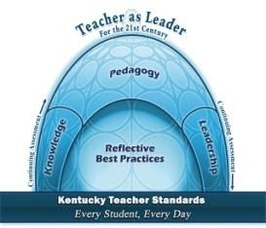
Ethical Case Study Writing Prompt
LWC Teacher Performance Assessment
During the student teaching experience, you have had the opportunity to work closely with students, teachers, and parents in the real world of the classroom. The dynamics of the classroom have required you to respond to many situations demonstrating the educator dispositions that you possess. Dispositions are your characteristic manners of behaving and responding to these situations that flow from your underlying values and beliefs, and are informed by your reasoning, perceptions, and experiences. The dispositions identified by the Lindsey Wilson College Division of Education that graduates of the program should demonstrate are contained in the fourth Key Concept, Reflective Best Practice. These are identified as Program Student Learning Outcomes and the specific dispositions identified are:
- Caring, ethical behavior
- Reflective, self-assessing thinker
- Professional growth and behavior
To demonstrate your growth and mastery of these dispositions during your student teaching experience, complete the following steps to write a case study and reflective analysis.
- Reflect on your student teaching experience and those incidents in which you displayed the educator dispositions.
- Select an incident when you, as a pre-service teacher, were required to demonstrate caring, ethical behavior.
- Write a brief summary narrative of the incident
- Clearly state the course of action that you took which demonstrated the disposition of a caring, ethical educator.
- Write a reflection of the case, stating
  - The ethical question(s) or dilemma(s)
  - Why you chose the action that you did
  - The theory or beliefs that were the base for your choice (Use information learned in the Classroom Management course and in your psychology / development courses as well as from your reading).
  - State whether you feel you made the “best” decision for the situation and why
  - What will you do the same or differently next time when confronted with a similar situation?
  - Explain how you have grown in demonstrating the ethic of care and in your ability to make ethical decisions in the classroom.
The Value Rubric for Ethics will be used to assess your Case Study.
Ethical Theories and Principles

