EDUC 5133
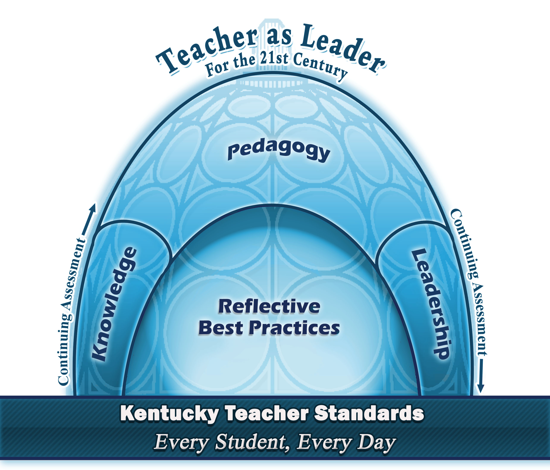

Assessment, Accountability, and Student Learning
Fall – 2018
Online

Professor: Dr. Gera Nelson
Office: 208 Goodhue
Office Hours: M-W-F: 11:20 – 1:30 & 2:20 - 4:20
T-TR: By appointment only

Phone: Office: 270-384-7331 -
Cell: 229-942-0866
E-mail: nelson@lindsey.edu

Required Text:
- Stiggins, R. J., & Arter, J. A., Chappuis J., & Chappuis, S. (2004). Classroom Assessment for Student Learning. Portland, OR: Assessment Training Institute.
- Reeves, D. B. (2004). Accountability for Learning: How Teachers and School Leaders Can Take Charge.Association for Supervision and Curriculum Development., Alexandria - VA

Course Description:
Students will examine the construction of criterion-referenced and norm-referenced testing instruments administered to Kentucky students. This class addresses how teachers analyze and use test results to improve student performance. Students will develop assessments using state testing formats (on demand writing, selected and open/written response questions with scoring rubrics, formative and summative assessments) as well as understand the Kentucky Performance Reports (KPR).

Conceptual Framework:
The Division of Education and the Unit for Teacher Preparation supports its philosophy and motto “Teacher as Leader for the 21st Century” through a rigorous professional education curriculum and through their Conceptual Framework. Knowledge, pedagogy, leadership, and reflective best practice are the four key concepts of the Conceptual Framework of which each program is based. This philosophy and motto is the foundation for all activities and coursework.

Senate Bill 1 Initiatives
This course will provide students an opportunity to advance their knowledge and mastery of the “tools” associated with Kentucky education reform, including the Kentucky Core Academic Standards, Characteristics of Highly Effective Teaching and Learning, College and Career Readiness, literacy and assessment for learning,. As students carry out projects and complete assignments that involve instructional activities for P-5 students in Kentucky schools, they will address one or more components of the Senate Bill 1 initiatives.
Technology
Candidates are required to use technology for class assignments, lesson plan design and preparation, class presentations and record keeping. Candidates are required to successfully complete course work that focuses on using technology. Candidates are required to communicate via electronic mail, access the Internet and online databases, and use digital texts and modes for projects and presentations.

Course Objectives:
The purpose of this course is to provide students with knowledge and skills to administer, score, and analyze data leading to improved instruction and student performance. Upon successful completion of this course students will be able to:

1. Demonstrate understanding of testing practices used in Kentucky. (Program Goal: Knowledge)
2. Analyze KPR test scores incorporating Digital Literacy, Effective Communication, and Inventive Thinking skills. (Program Goal: Knowledge)
3. Develop appropriate and high quality tests and rubrics using a variety of test question types that address assessment for learning. (Program Goal: Knowledge)
4. Interpret standardized test scores (EPAS) and explain results to students, caregivers, and other school personnel. (Program Goal: Knowledge, Pedagogy, Leadership)
5. Demonstrate 21st century skills such as Inventive Thinking and Effective Communication to develop different types and styles of assessments (formal and informal, as well as formative and summative). (Program Goal: Knowledge, Pedagogy)
6. Interpret student test data including EPAS to identify strengths and/or areas for growth in the 21st century classroom. (Program Goal: Knowledge, Pedagogy, Leadership)

Course Requirements/Assessment Tasks

1. Analysis of Student Work
Candidates will explore a variety of protocols used in the analysis of student work. They will evaluate protocols related to their school’s need and the express purpose of the protocols, understanding that a variety of protocols need to be at a school’s disposal and used based on the express need of the school. They will design an implementation model for a protocol of their choice. Student will identify and understand the usefulness of analysis protocols in gathering and using student data to enhance instruction and close achievement gaps.

2. Test Writing Project and Rubric
Candidates will write a test using different types of questions (i.e.: multiple choice, fill-in-the-blank, matching, short answer, essay/open response) and create a scoring rubric that is aligned with Content 4.1/Kentucky Academic Standards (KAS) or end of Course Exam as appropriate. This should be an assessment that will be administered in students’ classes the following week and results used for the upcoming analyzing student work session.
3. Performance Assessment Task and Rubric
Candidates will write a performance assessment task (pre-post test) with an accompanying scoring rubric that is aligned with Content 4.1/Kentucky Academic Standards (KAS). This should be a task that will be administered in students’ classes with the results used for future assignments.
4. Standardized Test Analysis
Candidates will find three multiple choice items and one constructed response items from each of four
different states’ tests. Students will analyze selections for level of Blooms’ Taxonomy and determine the level of thinking required for questions. Candidates will show how each item can be used in a K-PREP Cumulative
Assessment.
5. Leadership Reflection Journals
Candidates will complete weekly journals recording effectiveness and appropriateness of implemented
strategies, activities, and appropriate topics.

All work is due on assigned date even if you are absent

Grading
Grades will be assigned on the basis of accumulated points at the end of the semester. Points are earned through the completion of activities, attendance, and other assessment activities.

Class Participation 80
Grading Scale (Percent):

90-100 = A
80-89 = B
70-79 = C
60-69 = D
0-69 = F
Concept Presentation (PPT) 50
Weekly Reflections (40 each) 280
Performance Assessment Task 30
Sample test using ORQ & MC 50
CHETL Essay 50
CCR standard essay 50
Student Self Reflection 50
PLC model and Analysis of Student Work 100
Leadership Reflective Journal (4) 40
____________
780
Competencies:
Course Objectives | KTS  Advanced Level | ISTE | SISI | EPSB | CAEP | 21st Century Skills | Outcomes
1. Demonstrate understanding of testing practices used in Kentucky. | 1, 3, 5, 10 | 1.3, 2.4 | 2 | Diversity  Assessment  Literacy  Closing the Gap |  | Digital Literacy | Analysis of K-PREP  Test Writing  Examine test questions and level of thinking/response required.
2. Analyze KPR test scores incorporating Digital Literacy, Effective Communication, and Inventive Thinking skills. | 1, 5, 10 | 2.4 | 2 | Diversity  Assessment  Closing the Gap |  | Digital Literacy | Analysis of K-PREP  Essay  Leadership Reflective Journals.  Assessment literacy activity and discussion of points.  Balanced assessment
3. Develop appropriate and high quality tests and rubrics using a variety of test question types that address assessment for learning. | 1, 5 | 2.4  3.0 | 2, 7 | Assessment  Literacy  Closing the Gap |  | Digital Literacy  High Productivity  Inventive Thinking  Effective Communication | Testing Writing  Discussion of formative and summative assessments  Share data on use of formative strategies
4. Interpret standardized test scores and explain results to students, caregivers, and other school personnel. | 1, 3, 5, 10 | 2.4  3.0 | 2, 7 | Assessment  Literacy  Closing the Gap |  | Digital Literacy  High Productivity  Inventive Thinking  Effective Communication | Standardized Test Analysis  Leadership Reflective Journals
5. Demonstrate 21st century skills such as Inventive Thinking and Effective Communication to develop different types and styles of assessments (formal and informal, as well as formative and summative). | 1, 5 | 2.4  3.0  3.1 | 2 | Assessment  Closing the Gap |  | Digital Literacy  High Productivity  Inventive Thinking  Effective Communication | Performance Assessments  Standardized Test Analysis  Text complexity from KAS  Quantiles – explore web site  Quantile placemat  Lexiles
6. Interpret student test data to identify strengths and/or areas for growth in the 21st century classroom. | 1, 5 | 2.4 | 2 | Diversity  Assessment  Literacy  Closing the Gap |  | Effective Communication | Standardized Test Analysis  Examine test questions and level of thinking/response required.

Bold = Continuous Assessment

https://education.ky.gov/curriculum/standards/teachtools/Pages/Characteristics-of-Highly-Effective-Teaching-and-Learning-(CHETL).aspx

Class Dates, Activities, and Assignments
Always have text chapter read for the upcoming week’s discussion

Date | Topic | Activities | Assignments
Week – 1  August 20-25 | Introductions  New Accountability Model What is your understanding?  CHETL/teacher evaluation model  Formative and Summative assessment  CASL  Discussion of chapter - 1  Classroom Assessment: Every Student a Learner  Accountability for Learning  - Chapter – 1 the A- “Word” Why People Hate Accountability | Discuss Accountability White paper from KDE  Review CHETL document  Discuss formative and summative assessments  Share data on use of formative strategies | - Read the Accountability White Paper  Characteristics of Highly Effective Teaching and Learning (CHETL)  CHETL Assignment Find your content CHETL document  - Complete CHETL work sheets of section 1 and 2  https://education.ky.gov/curriculum/standards/teachtools/Pages/  Characteristics-of-Highly-Effective-Teaching-and-Learning-(CHETL).aspx
Week – 2  August 27-31 | Assessment Literacy  Balanced Assessment  EPAS  College and Career Readiness  Program Reviews  CASL  Discussion of Chapter - 2 Clear Purpose: Assessment FOR and OF Learning  Discussion of Chapter 3  Clear target  Accountability for Learning  - Chapter – 2 Accountability Essentials: Identifying and Measuring Teaching Practices | Assessment literacy activity and discussion of points.  Balanced assessment – CASL  EPAS system and new standards  How do you ensure that your students have clear targets? What changes are acceptable?  How do we deconstruct standards? | Reflection 1 Due  – August 25  CASL chapters 2 - 3
Week – 3  September 4-7 | CASL  Discussion of Chapter - 4  Sound Design  Discussion of Chapter - 5  Selected Response Assessment  Accountability for Learning  - Chapter – 3  The Accountable Teacher | Program review documents and regulations from KDE  How does my school support all of the program review components?  Explore other states’ released test items. Look at format, assess level of questions,  Examine test questions and level of thinking/response required. | - CCR Essay due  - Read Balanced Assessment Manifesto by Rick Stiggins (blackboard)  - CASL chapters 4 - 5  Saturday – September 08
Week – 4  September 10-14 | MC questions  CASL  Discussion of Chapter - 6  Written Response Assessment  Discussion of Chapter - 7  Performance Assessment  Accountability for Learning  - Chapter – 4  Teacher Empowerment: Bottom-up Accountability | ORQ power point – work with question type  On Demand requirements and strategies  KASC materials for short answer | - Reflection - 2 Due  September 15  - CHETL Assignment due September 16  - CASL chapters 6 - 7
Week – 5  September 17-21 | Written response  ORQ – types, writing of, scoring of  On Demand writing  Short answer questions  CASL  Discussion of Chapter - 8  Personal Communication as Classroom Assessment  Discussion of Chapter - 9  Record Keeping: Tracking Student Learning  Accountability for Learning  - Chapter – 5  A view from the District | Text complexity from KAS:  - Quantiles – explore web site  - Quantile placemat  - Lexiles  Analysis of student work protocols power point. Discussion of use in schools – how used and benefits – for students and teachers. | CASL chapters 8 - 9
Week – 6  September 24-28 | Text complexity  Quantiles  CASL  Discussion of Chapter - 10  Converting Summative Assessment Information into Grades  Discussion of Chapter - 11  Portfolios  Accountability for Learning  - Chapter – 6  The Policymaker’s Perspective | Target method match powerpoint (on web page)  Begin writing test for upcoming material you will teach. Be sure to use ideas and concepts we have discussed in class | Reflection – 3 - Due  Saturday – September 28  (This one needs to be about the process for determining text complexity)  Have KDE Advisory Model  CASL Chap 10-11  Assess a piece of literature using KDE system of determining text complexity.  Test writing assignment: get questions answered.  Due on September 25:  Choose a protocol and outline the procedures for implementation in your school as if you were going to conduct this with other teachers.  The objective of this assignment is that you in a position of leadership learn how to use a "Tuning Protocols" of assessments  This is your final paper/exam.
Week – 7  October 1-5 | ILP  Advising Model  Analysis of student work protocols  CASL  Discussion of Chapter – 12  Conferences About and With Students  Accountability for Learning  - Chapter – 7  Putting it All Together: Standards, Assessments and Accommodations | Performance assessment guidelines  Read and discuss CDL info  Read and discuss FAL  Write a performance assessment task and scoring rubric for your classes | Due: October 02  - Assessment task and rubric using CDL or FAL  - Write performance assessment and rubric
Week – 8  October 08-12 | Target method match in testing  Test Writing Project and Rubric  Performance Assessment task and rubric  Collaborative Design Literacy  Formative Assessment Lesson  Effective PLCs (power point) | Discuss PLC and function in schools, | Reflection – 4 - Due  Thursday – October 4  Final Paper due Thursday October 4  All assignments due.  Thursday October 4

LINDSEY WILSON COLLEGE

STATEMENTS FOR INCLUSION IN THE SYLLABUS

2018-2019

Academic Integrity
Academic integrity is essential to the existence of an academic community. Every student is responsible for fostering a culture of academic honesty, and for maintaining the integrity and academic reputation of Lindsey Wilson College. Maintaining a culture that supports learning and growth requires that each student make a commitment to the fundamental academic values: honesty, integrity, responsibility, trust, respect for self and others, fairness and justice.
To foster commitment to academic integrity, faculty are asked to require each student to place and sign the following honor code on tests, exams and other assignments as appropriate: On my honor as a student, I have neither given nor received any unauthorized aid on this assignment/exam.
Violations of the academic integrity policy include cheating, plagiarism, or lying about academic matters. Plagiarism is defined as any use of another writer’s words, concepts, or sequence of ideas without acknowledging that writer by the use of proper documentation. Not only the direct quotation of another writer’s words, but also any paraphrase or summary of another writer’s concepts or ideas without documentation is plagiarizing that writer’s materials. Academic dishonesty is a profoundly serious offense because it involves an act of fraud that jeopardizes genuine efforts by faculty and students to teach and learn together. It is not tolerated at Lindsey Wilson College.
Students who are determined to have plagiarized an assignment or otherwise cheated in their academic work or examinations may expect an “F” for the activity in question or an “F” for the course, at the discretion of the instructor. All incidents of cheating or plagiarism are reported by the instructor to the Academic Affairs Office along with copies of all relevant materials. Each instance of cheating or plagiarism is counted separately. A student who cheats or plagiarizes in two assignments or tests during the same semester will be deemed guilty of two offenses. If the evidence is unclear, or if a second offense occurs at any time in the student’s academic career, the Academic Affairs Office may, in consultation with the dean of students, refer the case to the Judicial Board for review. Violations will ordinarily result in disciplinary suspension or expulsion from the college, depending on the severity of the violation involved. Note: The college has access to a web product to detect plagiarized documents. Faculty members are encouraged to use this tool.

Questioning a Grade -- The Student Academic Complaint Policy
A student, who wishes to question an assignment grade, or other academic issue, should follow the procedure below:

- Whenever possible, the student will first go to the faculty member who has assigned the disputed grade. Complaints regarding grades should be made within seven (7) days of receipt of the disputed grade and, if possible, will be decided by the faculty member within seven (7) days of receipt. If the disputed grade is the final grade for the course, “receipt” is defined by when the final grade is posted online by the Registrar’s Office. (Please refer to the next section for appealing a final grade.)
- Unless there are extenuating circumstances, the student may, within seven (7) days, request in writing a review of such decision by the academic unit/division chair/director in which the grade was assigned. Upon receipt of such request, that chair/director will direct the faculty member and the student to each submit, within seven (7) days, if possible, a written account of the incident, providing specific information as to the nature of the dispute.
- Upon receipt of these written accounts, the chair/director will meet, if possible, within seven (7) days with the faculty member and the student in an effort to resolve the dispute and will render his or her decision in writing.
- If either the student or the faculty member desires to appeal the decision of the chair/director, the student or faculty member may, within seven (7) days by written request to the chair/director, ask that the matter be reviewed by a Grade Appeals Panel* convened by the Academic Affairs Office.
- If the disputed grade is assigned at the end of a fall or spring semester and the student and faculty member cannot meet to resolve the issue, the student should contact the faculty member by email within seven (7) days of receipt of the disputed grade. If the issue cannot be resolved by email within the time limit, steps 2, 3, and 4 of the appeal may extend into the beginning of the semester immediately following receipt of the disputed grade by following the timeline above.

A student who wishes to question a final grade should follow the procedure below:

- Confer with the faculty member who assigned the disputed grade.
- If the disputed grade cannot be resolved, a written request for a grade appeal must be submitted to the Academic Affairs Office within ten calendar days of when the grade was issued or before the first day of the semester following the one in which the grade was issued, whichever comes later. The written request must include the specific bases for the appeal.
- The Academic Affairs Office will convene a Grade Appeals Panel.*

*The grade Appeals Panel is comprised of the vice president for Academic Affairs, assistant vice president for Academic Affairs or the associate dean for the School of Professional Counseling, and the director/chair of the academic unit/division that houses the course for which the grade is appealed. If one of the members is the faculty member who issued the grade, an alternate will be appointed. The student and the faculty member may appear separately before the panel to explain their positions. The hearing is non-adversarial. Neither the faculty member nor the student may be accompanied by other individuals to the meeting of the Grade Appeals Panel. The Grade Appeals Panel will notify the student and the faculty member of its decision, if possible, within seven (7) days of the meeting.
Policy for Verification of Student Identity and Protection of Privacy
In compliance with United States Federal Higher Education Opportunity Act (HEOA), Public Law 110-315, all credit-bearing courses and programs offered through distance learning methods must verify that the student who registers for a distance education course or program is the same student who participates in and completes the course or program and receives academic credit. One or more of the following methods must be used:
a) A secure login and pass code;
b) Proctored examinations; and/or
c) Remote proctoring of one of more examinations using Tegrity or other technologies
Verification of student identity in distance learning must protect the privacy of student information. Personally identifiable information collected by the College may be used, at the discretion of the institution, as the basis for identity verification. For instance, a student requesting that their learning system password be reset may be asked to provide two or more pieces of information for comparison with data on file. It is a violation of College policy for a student to give his or her password to another student.
Detailed information on privacy may be located at: http://www.lindsey.edu/media/319883/Online%20Services%20Privacy%20Policy%204.20.12.pdf
Institutional Review Board (IRB) Policies
The Lindsey Wilson College Institutional Review Board (IRB) safeguards the rights and welfare of human participants in research and other research activities. Lindsey Wilson College faculty, staff, and students, which comprise its academic unites, and facilities, are subject to the IRB policies. This includes any research for which a research agreement (e.g., MOU) identifies Lindsey Wilson College Institutional Review Board (IRB) as the IRB of record. All student-led human subject research must have a LWC faculty sponsor. All faculty members and students conducting human subject research are required to submit documentation of training on research involving human subjects that has been completed within two years of the onset of the proposed research. Online training is available at https://phrp.nihtraining.com/users/login.php.
Statement on Disabilities
Lindsey Wilson College accepts students with disabilities and provides reasonable accommodation that will facilitate success. Depending on the nature of the disability, some students may need to take a lighter course load and may need more than four years to graduate. New students needing accommodation should apply to the college as early as possible, usually before May 15 for the fall semester, October 1 for the spring semester, and March 1 for the summer term. Immediately after acceptance, students must identify and document the nature of their disabilities with Mr. Ben Martin, the learning & physical disabilities coordinator. It is the responsibility of the student to provide the learning & physical disabilities coordinator with appropriate materials documenting the disability. Disabilities are typically documented by a recent high school Individualized Education Program (IEP) and results from testing conducted by a psychologist, psychiatrist, or a qualified, licensed person. The college does not provide assessment services for students who may be disabled. Although Lindsey Wilson provides limited personal counseling for all students, the college does not have structured programs available for students with emotional or behavioral disabilities. For more information, contact Mr. Martin at (270) 384-7479.
Academic Success Center
Located in the T.D. & Rowena Everett Center, the Academic Success Center (ASC) offers peer tutoring to aid students in completing class assignments, preparing for examinations, and improving their understanding of content covered in a particular course. In addition, computers are available for students’ academic use. Online tutoring is provided for community campus and online students.
Students are encouraged to utilize the center as a resource for improving study strategies and reading techniques. The center also offers assistance with other academic problems. To schedule a live or online tutoring session or for further information or assistance, please contact Ms. Maretta Garner, tutor coordinator, at (270) 384-8037 or at garnerm@lindsey.edu.
Writing Center and Mathematics Center
The Writing Center (located in the W. W. Slider Humanities Center), and the Mathematics Center (located in the Jim & Helen Lee Fugitte Science Building) are available for specialized tutoring at no charge to students. Please contact Jared Odd, writing center coordinator, at 270-384-8209 or Linda Kessler, math tutor coordinator, at 270-384-8115 for further information and assistance.
Final Exams
Final Exams for day classes are scheduled for the Fall 2018 semester on December 10-14 and May 6-10 for the Spring 2019 semester. (Check with instructors of eight-week long courses for finals dates.) The academic calendar, which contains the schedule for finals, is in the College Catalog and course schedule listing. Please make any necessary flight arrangements after final exams. Students will not be permitted to take early finals unless extenuating circumstances exist. “Extenuating circumstance” means illness, a verified family emergency or participation in officially sponsored travel in support of an event arranged by the College. Travel arrangements must be made in sufficient time that tickets may be obtained after final exams and the semester is officially over. All requests for early finals must be made in person to the Academic Affairs Office.
Email Policy
All Lindsey Wilson College students are required to communicate with LWC faculty and staff via LWC (Lindsey.edu) email addresses only. Alternative email addresses should not be used when communicating with LWC faculty and staff.
Cell Phone Policy
Student cell phones will be off during class time unless prior arrangement is made with the instructor.
Adding/Dropping a Course
Students enrolled in the following courses cannot drop these classes during the semester: READ 0713, 0723, 0733, 0903, 1013 and 1023; STSK 1003; ENGL 0903 and 0904; and ESL 0803, 0804 and 0854.
For undergraduate classes at the A.P. White Campus in Columbia and for online students, adding a course, dropping a course, or changing from one section of a course to another section of the same course requires the approval of the advisor and, after the term begins, of the instructor for each course involved as indicated on the Drop/Add Form. The change must be reported to the Business Office and the Registrar's Office on a Drop/Add/Drop, which may be obtained from the Registrar's Office or online. For courses at the Scottsville campus, adding a course, dropping a course, or changing from one section of a course to another section of the same course requires the approval of the Scottsville enrollment manager. For courses taught at community campuses, adding a course, dropping a course, or changing from one section of a course to another section of the same course requires the approval of the site enrollment coordinator for the campus. Permission to add courses will not be given after the last date for late registration. Authorization for dropping a course will not be approved after more than 75 percent of the instructional days for a course are completed, as indicated by the college’s academic calendar.
If changes are not properly approved and officially reported as stated above, students will receive a grade of F in the courses for which they are officially registered, and they will be charged for all such courses. Students will not receive credit for changed or added courses unless they officially register for those courses.

Bibliography:

Bernhardt, Victoria. (1999). School Portfolio: Comprehensive Framework For School Improvement, (2nd ed.). Larchmont, NY: Eye on Education.

Bernhardt, Victoria. (2000). The Example School Portfolio: A Companion to The School Portfolio. Larchmont, NY:
Eye on Education.

Freiberg, J., & Driscoll, A. (2000). Universal teaching strategies (3rd ed.). Needhan Heights, MA: Allyn & Bacon.

Kentucky Department of Education (2006). Combined curriculum documents, 4.1. Frankfort KY. Division of Curriculum Development.

Kentucky Department of Education (2006). Program of studies for Kentucky school: GraAlldes primary – 12. Frankfort KY. Division of Curriculum and Assessment Development.

Rogers, S., & Graham, S. (2000). The high performance toolbox. (3rd ed.). Evergreen, CO: Peak Learning Systems.

Silver, H., Strong, R. & Perini, M. (2000). So each may learn: Integrating learning styles and multiple intelligences. Alexandria, VA: ASCD.

Sprenger, M. (1999). Learning & memory: The brain in action. Alexandria, VA: ASCD.

Strong, R., Silver, H., & Perini, M. (2001). Teaching what matters most: Standards for Raising student achievement. Alexandria, VA: ASCD.

Wong, H., & Wong, R. (1991). The first days of school: How to be an effective teacher. Sunnyvale, CA: Harry K. Wong Publications.

